FML UNIT 3

Dimensionality reduction:

1. What is Dimensionality Reduction?
- Dimensionality reduction is the process of reducing the number of input features (variables) in a dataset while keeping the most important information.
- It transforms high-dimensional data into a lower-dimensional space so that it becomes easier to analyze and process.
- Example: when we are building a model to predict house prices with features like bedrooms, square footage and location. If we add too many features such as room condition or flooring type, the dataset becomes large and complex.

2. Need for Dimensionality Reduction
- Simplifies Data
  - High-dimensional data is complex and difficult to handle.
  - Dimensionality reduction simplifies it without losing essential details.
- Improves Computation Speed
  - Fewer features mean faster training and testing of machine learning models.
- Prevents Overfitting
  - Too many features may cause models to learn noise instead of useful patterns.
  - Reducing dimensions helps in building more generalizable models.
- Better Visualization
  - Data with hundreds of dimensions cannot be visualized directly.
  - Reducing it to 2D or 3D makes visualization possible.
- Removes Redundancy and Noise
  - Many features are correlated or irrelevant.
  - Dimensionality reduction removes such redundancy and keeps only meaningful features.

3. How Dimensionality Reduction Works
- Imagine a dataset where every data point lies in a 3D space, represented by three axes: X, Y, and Z.
- When we analyze the data, we may notice that:
  - Most of the variance (useful information) is captured along X and Y axes.
  - The Z axis contributes very little to explaining the structure of the data.
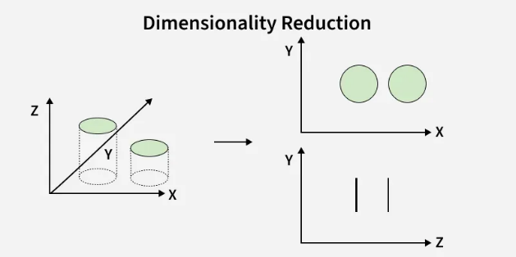

Before Dimensionality Reduction
- The data exists in full 3D (X, Y, Z) space.
- There is high redundancy, because the Z-dimension does not add much meaningful information.
- This makes the dataset more complex to process and analyze.

After Dimensionality Reduction
- We reduce the data from 3D to 2D by removing the less useful Z-dimension.
- The data is now represented in lower-dimensional space:
  - The X–Y plane still maintains the important structure and patterns.
  - The Z–Y plane shows that Z was not contributing significantly.

Result
- By removing the unimportant Z-dimension:
  - Computation becomes faster because fewer features are used.
  - Visualization becomes easier since data is now in 2D.
  - Redundancy is minimized, making analysis more efficient.

  - Dimensionality Reduction Techniques

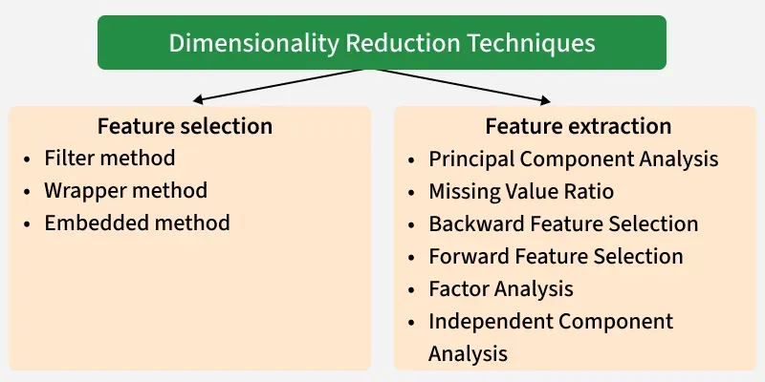
Dimensionality reduction can be done in two main ways:

A. Feature Selection
- Feature selection chooses the most important features from the dataset without changing them.
- It removes irrelevant or redundant features, making the dataset simpler and improving model performance.
Common Methods of Feature Selection:
- Filter Methods
  - Features are ranked based on their statistical relationship with the target variable.
  - Only the most relevant features are selected.
  - Example: Using correlation scores or chi-square tests.
- Wrapper Methods
  - Features are selected based on how well they improve model performance.
  - This is like a trial-and-error approach: add/remove features and check accuracy.
  - More computationally expensive than filter methods.
- Embedded Methods
  - Feature selection happens during model training itself.
  - Example: Decision trees automatically give importance scores to features.
  - It combines both feature selection and learning at the same time.

B. Feature Extraction
- Instead of selecting original features, this method creates new features by combining or transforming existing ones.
- The new features preserve most of the important information but exist in fewer dimensions.
Common Methods of Feature Extraction:
- Principal Component Analysis (PCA)
  - Converts correlated variables into a smaller set of uncorrelated variables called principal components.
  - Captures maximum variance in the data with fewer dimensions.
  - Useful for visualization and speeding up analysis.
- Missing Value Ratio
  - Features with too many missing values (beyond a set threshold) are removed.
  - Helps in cleaning the dataset and improving reliability.
- Backward Feature Elimination
  - Start with all features in the dataset.
  - Remove the least important feature step by step.
  - Continue until only the most significant features are left.
- Forward Feature Selection
  - Start with no features.
  - Add one feature at a time and keep it only if it improves performance.
  - Repeat until the best set of features is selected.
- Random Forest Method
  - Uses decision trees to calculate the importance of features.
  - Automatically selects the most relevant ones.
  - Reduces manual work and often improves model accuracy.
- Factor Analysis
  - Group together features that are highly correlated with each other.
  - Keeps only the most meaningful groups for further analysis.
- Independent Component Analysis (ICA)
  - Finds components that are statistically independent from each other.
  - Very useful in situations like blind source separation (e.g., separating multiple overlapping sound signals).
Difference between PCA and ICA:
Aspect | PCA (Principal Component Analysis) | ICA (Independent Component Analysis)
Goal | Find directions that capture maximum variance | Find components that are statistically independent
Relationship between components | Uncorrelated (orthogonal) | Independent (not necessarily orthogonal)
Mathematics used | Covariance matrix, eigenvectors, eigenvalues | Higher-order statistics (e.g., kurtosis, negentropy)
Output | Principal components (linear combinations of original variables) | Independent components (hidden sources/signals)
Use cases | Dimensionality reduction, noise reduction, visualization | Source separation (e.g., separating audio signals, brain signal analysis)
Interpretation | Captures the main “spread” of the data | Extracts underlying hidden factors/signals
Example | Rotate data axes to maximize variance | Separate two mixed voices recorded by one microphone
  - Real-Life Use Cases
- Text Categorization – Classifying documents into categories by reducing word/phrase feature space.
- Image Retrieval – Indexing and searching images using visual features like color, texture, shape.
- Gene Expression Analysis – Identifying key features in biological data (e.g., classifying leukemia samples).
- Intrusion Detection – Detecting unusual patterns in cybersecurity by reducing irrelevant network features.
  - Advantages
- Faster computation and training.
- Easier data visualization.
- Helps prevent overfitting and improves generalization.
  - Disadvantages
- Possible data loss leading to reduced accuracy.
- Hard to decide how many dimensions to keep (risk of too much or too little reduction).

Principal Component Analysis (PCA)

1. What is PCA?
- PCA is a dimensionality reduction technique used in data analysis and machine learning.
- It reduces the number of features (dimensions) in a dataset while keeping as much useful information as possible.
- The main goal of PCA is to simplify large datasets for easier computation, visualization, and better model performance.
- PCA does this by identifying new directions (called principal components) along which the data varies the most.

2. How PCA Works

PCA transforms the dataset into a new coordinate system step by step:
- Standardization of Data
  - First, all features are standardized (mean = 0, variance = 1).
  - This ensures that features with large scales (e.g., income in lakhs vs. age in years) do not dominate the analysis.
- Covariance Matrix Computation
  - A covariance matrix is calculated to understand how features vary with respect to one another.
  - It shows the relationships and correlations between features.
- Eigenvalues and Eigenvectors
  - Eigenvectors of the covariance matrix represent the new directions (principal components).
  - Eigenvalues represent the amount of variance captured by each component.
  - The first principal component captures the highest variance, the second captures the next, and so on.
- Selection of Principal Components
  - Not all components are needed.
  - Only the top "k" principal components with the highest eigenvalues are selected, based on how much variance they capture.
- Transformation of Data
  - The original dataset is projected onto these principal components.
  - As a result, the data is represented in fewer dimensions but still carries most of the useful information.

3. How PCA Transforms Data
- PCA creates new features (principal components) that are linear combinations of the original features.
- These components are uncorrelated with each other, reducing redundancy.
- Example:
  - Suppose you have features "height" and "weight" that are highly correlated.
  - PCA may combine them into a new component like "body size," which reduces duplication of information.
- This makes the dataset smaller, less noisy, and easier to analyze or visualize (for example, converting 3D data into 2D while keeping important trends).

✅ Advantages of PCA
- Simplifies data (fewer dimensions).
- Removes redundancy & noise.
- Speeds up model training.
- Makes visualization easier.
- Solves multicollinearity issues.

❌Disadvantages of PCA
- Hard to interpret components.
- Some information is lost.
- Needs feature scaling.
- Works only with linear patterns.
- Heavy for very large datasets.

🎯 Applications of PCA
- Data Visualization → reducing many variables into 2D/3D plots.
- Image Compression → reducing pixel data while keeping main features.
- Noise Reduction → filtering out irrelevant variations in data.
- Finance → analyzing stock price movements by extracting key factors.
- Genomics & Biology → reducing huge gene expression datasets.
- Recommendation Systems → simplifying user-item interaction data.

Linear Discriminant Analysis (LDA)

1. What is LDA?
- Linear Discriminant Analysis (LDA) is a supervised machine learning technique.
- It is mainly used for classification and dimensionality reduction.
- The method reduces the number of features but still keeps the information that is most important for distinguishing between classes.
- The goal is to project data into a lower-dimensional space where:
  - Different classes are separated as much as possible.
  - Samples of the same class are kept close together.
- Unlike PCA (which ignores class labels), LDA uses class label information to find the best separation between groups.

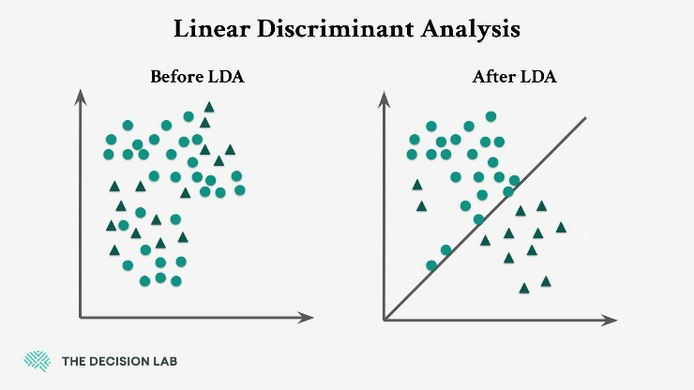

2. How LDA Works
- Class Separation
  - LDA finds new axes (linear combinations of features) that best separate different classes.
  - It does this by:
    - Maximizing the distance between class means (between-class variance).
    - Minimizing the variance within each class (within-class variance).
- Steps of LDA
  - Compute the mean of each class.
  - Compute the scatter within each class (how spread out the data is).
  - Compute the scatter between classes (distance between class means).
  - Find the projection (new axis) that maximizes the ratio of between-class scatter to within-class scatter.
  - Project the data onto this new axis for better class separability.

3. Example
- Suppose you have two classes of flowers, each with multiple features like petal length, petal width, etc.
- If you use just one feature, the classes may overlap and be hard to separate.
- LDA uses a combination of all features to create a new axis where the classes are more distinctly separated.

4. Advantages
- Reduces dimensions while preserving class separability.
- Improves classification accuracy.
- Works well with linearly separable data.
- Helps in visualizing high-dimensional datasets.

5. Disadvantages
- Assumes data is normally distributed (Gaussian).
- Assumes equal covariance across classes.
- Not effective if classes are not linearly separable.
- Performance drops with non-Gaussian or overlapping data.

6. Applications
- Face recognition (separating different faces).
- Medical diagnosis (classifying diseases).
- Marketing (customer segmentation).
- Speech recognition (separating different speakers).

Difference Between PCA and LDA

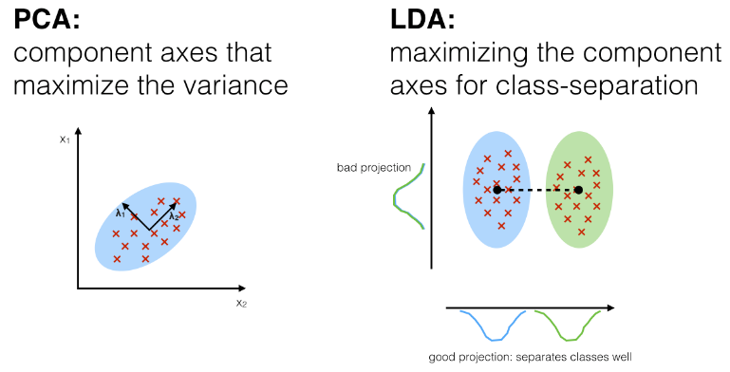
Aspect | PCA (Principal Component Analysis) | LDA (Linear Discriminant Analysis)
Goal | Reduce dimensions by maximizing variance in data. | Reduce dimensions by maximizing class separability.
Type | Unsupervised (does not use class labels). | Supervised (requires class labels).
Focus | Focuses on finding directions (principal components) that capture the most variance. | Focuses on finding directions that best separate different classes.
Resulting Components | Components are uncorrelated linear combinations of original features. | Components are linear combinations chosen to maximize class distinction.
Use Cases | Useful for data compression, visualization, noise reduction. | Useful for classification problems where class separability is important.
Example | Reducing a dataset of customer preferences into fewer dimensions for clustering. | Reducing image data to separate "cat" and "dog" classes for classification.

Shrinkage Methods in Machine Learning

1. Introduction
- In regression analysis, we often face the problem of overfitting, especially when the dataset has many predictors (features) or when predictors are highly correlated.
- Overfitting means that the model fits the training data very well but fails to generalize to new, unseen data.
- Shrinkage methods are used to solve this issue. They work by adding a penalty term to the regression cost function, which reduces (or “shrinks”) the size of the regression coefficients.
- By shrinking coefficients:
  - The model becomes simpler.
  - Multicollinearity is reduced.
  - Generalization to new data improves.

2. Why Shrinkage is Needed
- Ordinary Least Squares (OLS) regression estimates coefficients by minimizing the sum of squared errors. However, when predictors are highly correlated or when the number of predictors is very large, OLS can give unstable and large coefficients.
- Shrinkage methods add a regularization penalty to control the size of coefficients.
- This helps in:
  - Preventing overfitting.
  - Improving model stability.
  - Handling high-dimensional data.

3. Types of Shrinkage Methods

(A) Ridge Regression (L2 Regularization)
- Ridge regression adds a penalty equal to the sum of squares of the coefficients.
- The cost function becomes:

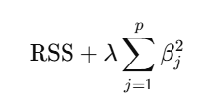
- Here, λ is the regularization parameter that controls the strength of the penalty.
- Ridge shrinks coefficients towards zero but never makes them exactly zero.
- It is most useful when:
  - All predictors contribute to the outcome.
  - We want to reduce their impact but not remove them completely.

(B) Lasso Regression (L1 Regularization)
- Lasso adds a penalty equal to the sum of the absolute values of coefficients.
- The cost function becomes:

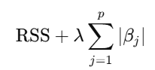
- The penalty forces some coefficients to become exactly zero, effectively removing them from the model.
- Hence, Lasso performs both:
  - Shrinkage (reducing coefficient values).
  - Feature Selection (removing irrelevant features).
- It is most useful when:
  - We suspect that only a few predictors are important.
  - Automatic feature selection is desired.

(C) Elastic Net
- Elastic Net is a combination of Ridge (L2) and Lasso (L1).
- The cost function becomes:

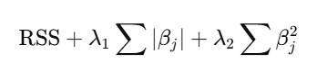
- It balances between:
  - Ridge’s ability to handle correlated predictors.
  - Lasso’s ability to perform feature selection.
- It is most useful when predictors are highly correlated and we want both shrinkage and feature elimination.

Compare and contrast shrinkage methods with subset selection techniques
Aspect | Shrinkage Methods | Subset Selection Techniques
Goal | Reduce coefficient sizes, prevent overfitting | Select the most important predictors
Feature Selection | Lasso/Elastic Net can select automatically | Explicitly selects or removes variables
Handling Correlated Features | Ridge and Elastic Net handle correlation well | Can be unstable with correlated predictors
Coefficient Handling | Coefficients are shrunk (not all zero in Ridge) | Removed variables have coefficients set to zero
Computation | Efficient for high-dimensional data | Can be expensive for large datasets
Overfitting Control | Regularization prevents overfitting | Reducing model size reduces overfitting

Separating Hyperplanes & SVM

Support Vector Machine (SVM)

1. Introduction
- Support Vector Machine (SVM) is a powerful supervised machine learning algorithm used for both classification and regression, but mainly for classification tasks.
- It is based on the concept of finding an optimal separating hyperplane that best divides different classes of data.

2. Concept of SVM
- Among all possible separating hyperplanes, SVM chooses the one that has the maximum margin between the two classes.
- Margin means the distance between the hyperplane and the nearest data points from each class.
- The data points that lie closest to the hyperplane and define the margin are called support vectors.

3. How SVM Works
- Plot data points in the feature space.
- Identify a hyperplane that separates the classes.
- Measure the distance (margin) between the hyperplane and the nearest points of both classes.
- Select the hyperplane with the largest margin – this ensures better generalization to new data.

SVM is a machine learning method that finds the best way to separate classes. It does this using a separating hyperplane, which is a line or plane that divides the data so that different classes lie on opposite sides.

Classification Using Separating Hyperplanes

1. Introduction
- Classification in machine learning is the process of assigning data points to predefined classes or categories.
- One important approach to classification is using a separating hyperplane.
- A hyperplane is a flat surface (line in 2D, plane in 3D, or higher-dimensional equivalent) that divides the feature space into different regions.

2. Concept of Separating Hyperplanes
- Suppose we have two classes of data points in a feature space.
- A separating hyperplane is a boundary that divides the space in such a way that:
  - Data points of one class lie on one side.
  - Data points of the other class lie on the opposite side.
- In 2D space, the hyperplane is just a straight line.
- In 3D space, the hyperplane becomes a flat plane.
- In higher dimensions, it generalizes to a flat subspace called a hyperplane.

3. Mathematical Representation
- A hyperplane can be written as:

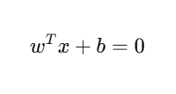

where:
  - w= weight vector (defines orientation of the hyperplane)
  - x = input feature vector
  - b = bias/offset (defines the position of the hyperplane)
- Classification is then done as:

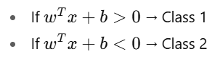

4. Example
- Consider a dataset of students with two features: study hours and test scores.
- We want to classify them into “Pass” or “Fail”.
- A straight line (2D hyperplane) can be drawn such that:
  - Students above the line are classified as “Pass”.
  - Students below the line are classified as “Fail”.

5. Use in Machine Learning
- Separating hyperplanes are the foundation of several algorithms:
  - Perceptron (basic linear classifier).
  - Support Vector Machines (SVMs) – find the optimal hyperplane that maximizes the margin between classes.
- Works best when the classes are linearly separable.

6. Advantages and Limitations

Advantages:
- Simple and computationally efficient.
- Provides clear decision boundaries.

Limitations:
- Works only when data is linearly separable.
- Struggles with overlapping or non-linear class boundaries.

